ASSIGNMENT-4.2

NAME:K.Ram charan

Hall ticket no:2403a51305

Batch no-13

**Task Description#1**

* **Zero-shot:** Prompt AI with only the instruction — Write a Python function to generate the Fibonacci sequence up to n terms acci sequence up to n terms
* 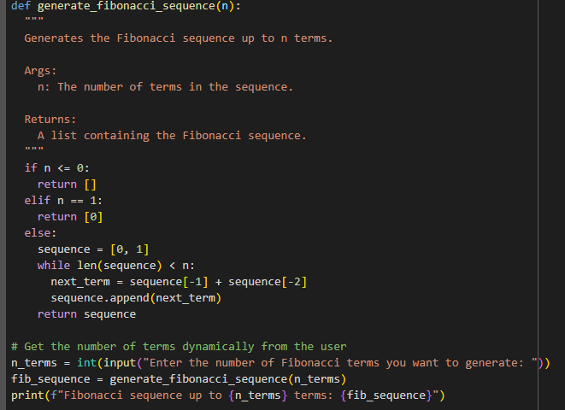

Output:

Screenshot 2025-08-18 160528.png

**Task Description#2**

* One-shot: Provide one example: Input: 100, Output: 37.78 to help AI generate a function that converts Fahrenheit to Celsius.

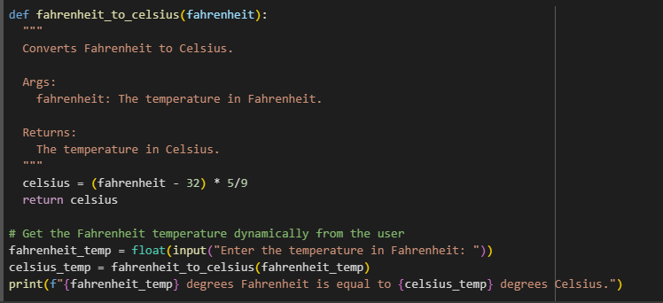

Output:

Screenshot 2025-08-18 160827.png

**Task Description#3**

* **Few-shot:** Give 2–3 examples to create a function that extracts the domain name from an email address.

1.

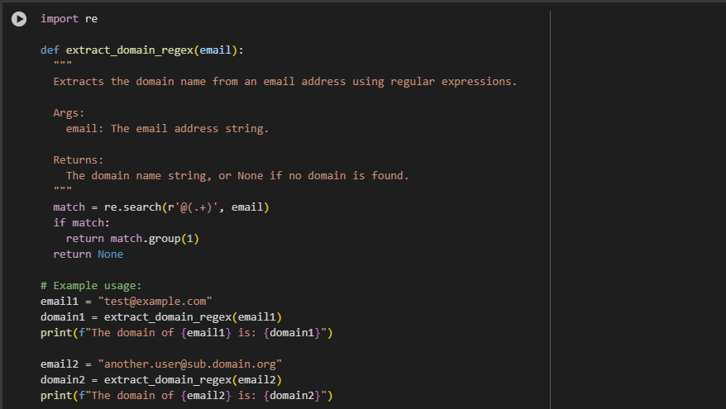

Output:

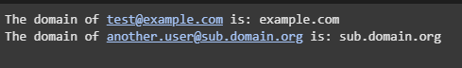

2.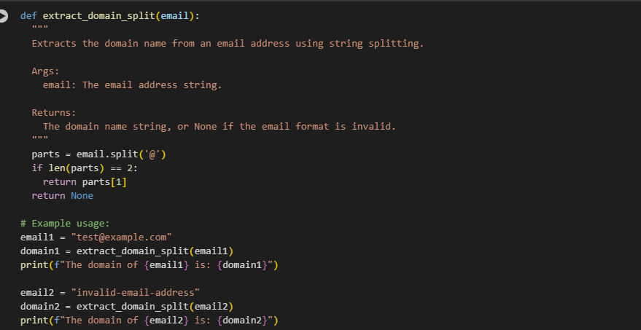

Output:

Screenshot 2025-08-18 155728.png

**Task Description#4**

* Compare zero-shot vs few-shot prompting for generating a function that checks whether a word is a palindrome, ignoring punctuation and case.

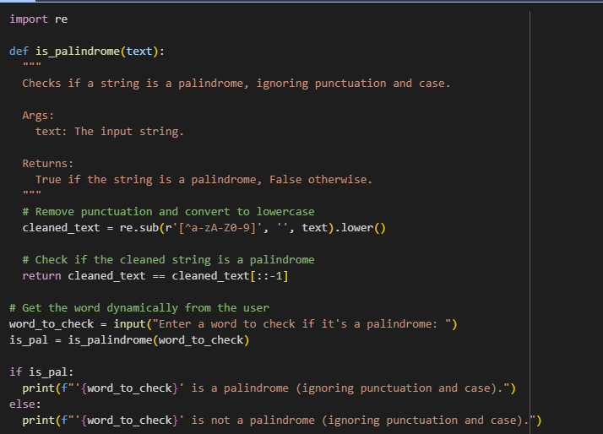

**Output:**

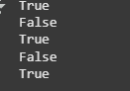

* **TASK:5**
* Use few-shot prompting with 3 sample inputs to generate a function that determines the maximum of three numbers without using the built-in max() function.

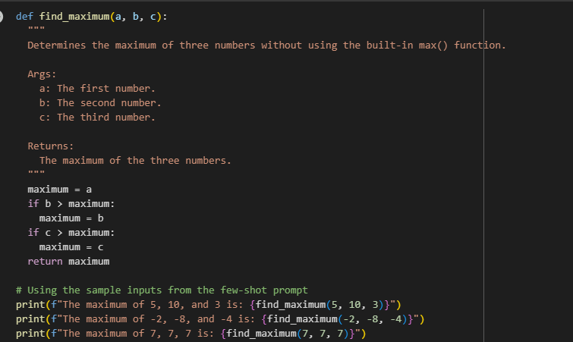

**Output:**

